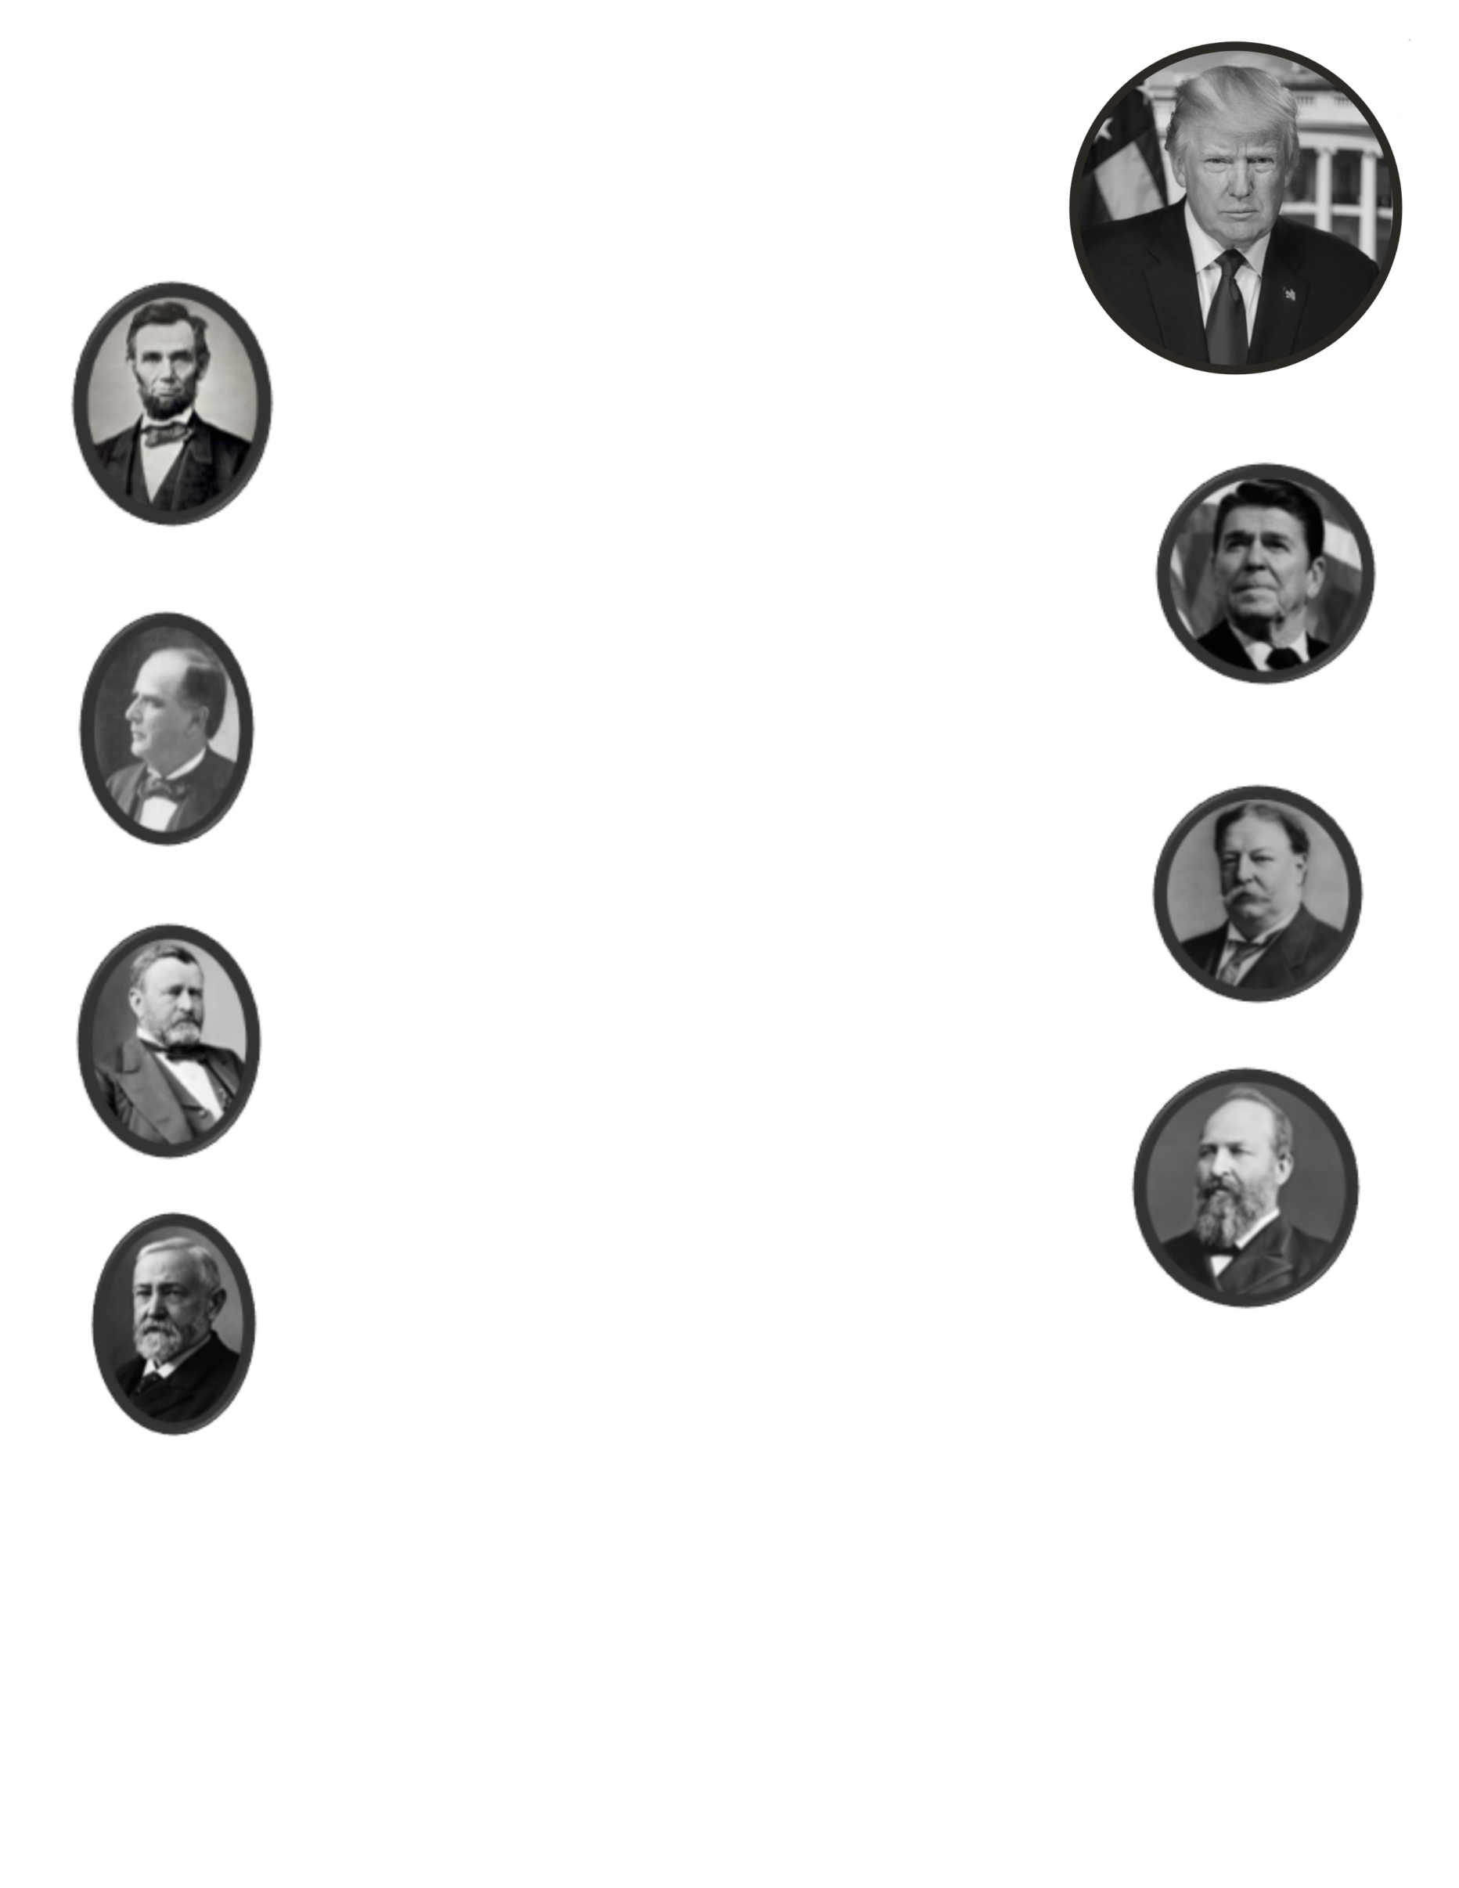
WE ARE TURNING ASHTABULA COUNTY RED!
*** Financial donors are needed to keep the democrats and their obstructionist ways from
creeping back into our progress. We MUST NOT let our guard down! President Trump
and I agree on many things one of which is how critical it is to keep your base engaged
in the political process. I’m asking the 15,000 Republicans in Ashtabula County to take
a few minutes to help us send the democrats packing in 2018! Be proud of our success
as Republicans! Let’s keep and build on what you and I started for our families!
Sincerely, Chairman Charlie Frye, Ashtabula County, Ohio!

With your approval all sponsors will be listed on our party website:
www.ashtabulagop.com

Lincoln Sponsor: $1000
Listed as a host of all Republican Party events for 2018.
You receive 4 VIP tickets to the Reagan Legacy Breakfast,
Oktoberfest, Judicial Salute and Christmas Party.

Reagan Sponsor: $500
Listed as a host for all Republican Party events for the 2018 year.
You receive 2 VIP tickets to the Reagan Legacy breakfast,
Oktoberfest, Judicial Salute and Christmas Party.

McKinley Sponsor: $250
Listed as a Sponsor for our Reagan Legacy Breakfast, Oktoberfest and
Christmas Party. You receive 2 VIP tickets for each event you Sponsor.

Taft Sponsor: $100
Listed as a Sponsor for our Reagan Legacy Breakfast and Oktoberfest.
You receive 2 tickets to both events.

Grant Sponsor: $50
Listed as a sponsor of the Ashtabula County Republican Party
on our website. You will receive a choice of 2 tickets to the
Oktoberfest or Reagan Legacy Breakfast and a MAGA hat.

Garfield Sponsor: $25
Listed as a sponsor of the Ashtabula County Republican Party on
our website. You will receive a MAGA hat.

Harrison Sponsor: $10 or less
Listed as a sponsor of the Ashtabula County Republican Party on our website.

Please note: VIP’s get opportunities to meet featured speakers in private
receptions before events and first chance at tickets to any PRESIDENT TRUMP rallies the ACRP
receives based on contribution level

I WANT TO BE A SPONSOR! Enclosed is a check for $______________________
Do you want to be listed as sponsor on our website? (circle one) YES NO
Make checks payable to: Ashtabula County Republican Party
Address: P.O. Box 650 Ashtabula, OH. 44005-0650
Corporate checks to: ACRP Restricted account
Supporting a Judicial candidate? Make check to: ACRP Judicial fund
Paid for by ACRP, Gary Gersin, Treasurer P.O. Box 650 Ashtabula, OH. 44005-0650

